Mr. Brad Daniels
C/o Brown Daniels Associates Inc.
12 Drummond Street, Suite 1
Etobicoke, ON M8V 1Y8 Info@iwfstoronto.org
http://www.iwfstoronto.org
http://www.iwfs.org

The International Wine & Food Society
Toronto Branch
Tuesday, June 23, 20
To: Karen Lefeu@hotmail.com
Cc PesidenI WFS Toronto
Subject: IWFS Dinner at Restaurant LaFeu

Reference: IWFS event date TBD

Dear Front of the House

I am representing the International Wine and Food Society of Toronto (IW&FS Toronto chapter). This is an international group with chapters around the world.
IWFS Event Structure

The dinner events, start at 6:30PM to 10:30PM are usually with 25 to 35 people and are moderately price sensitive <$130 all in. The age range of members is 45 & up. Extravaganza events are Black-Tie and usually have 45-55 people in attendance
<$225 all in.

Opening wine & hors d'oeurve circulation cocktail type greeting and tasting.
Sit-down dinner Amuse bouche & 4 courses with a commensurate wine at each course. Desert and a sweet wine. Regular water (tap), Coffee/Tea

Our Wine Cellar Director, David Beauroy, in consultation with your Chef marries the wine with the food, depending on the theme selected, French is always popular, however we can have some fun with this to allow the kitchen to stretch their creativity and resourcefulness. Wines are delivered the day before or the day of the event to the venue and are to be stored under proper temperature conditions.

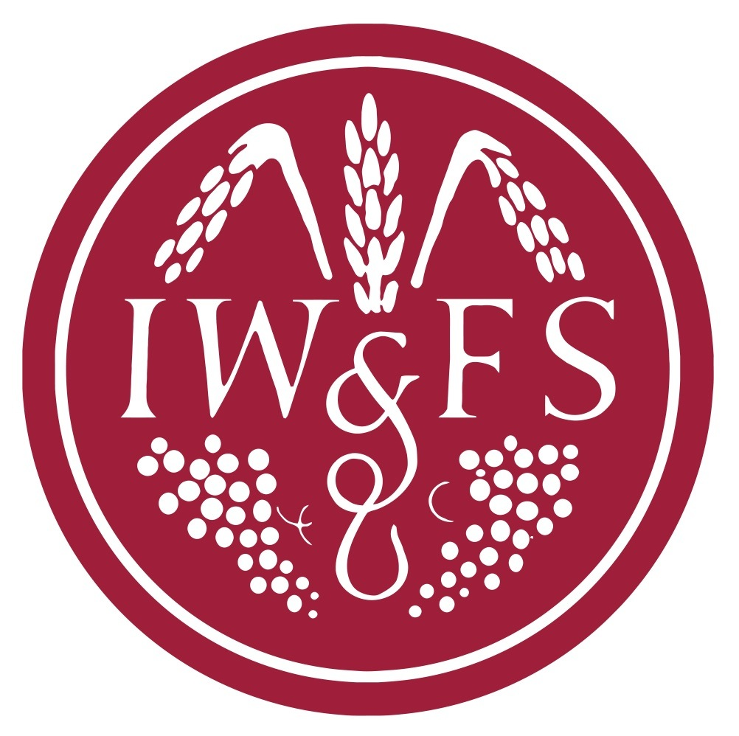
The wine is supplied and paid for by the IW&FS members, with no additional fees from the venue. Pours are 2oz as there are wines with each course.
Event Service
Event Wine

Our preferred dates are a Monday/Tuesday in the third week of the month starting at 6:30 PM in the winter to early summer 2015. The IWFS Sommelier or guest will address the wines served, therefore a separate room is good. So as to not interfere with other venue guests or the entire venue area as private event.
Event Dates

Suggested venue menu & costing
Event Pricing
Event pricing submission by the Venue for the suggested menu.
The menu would be designed around our wines and in consensus with the Chef, the theme or which wines are to be showcased.
Pricing, is all in including HST and Gratuities and any other extras per person.
Sufficient & quality glassware is to be venue supplied. Additional arrangements can be made, if required, for extra glassware.
Proper linen & table setup maximum tables size 6, this is flexible.
Tap Table water is included.
Venue Pricing
Individuals can separately procure other items from the venue, but it is the responsibility of individual and the venue and is not covered in any way by IWFS Toronto.

Number of participants is given to the venue 48 hours in advance and is our guarantee minimum. The venue should be able to accommodate 10% extra over the guaranteed minimum with in place seating, which will be covered at the per person cost should there be late registrants.
IWFS Guarantee
Payment is made at the end of the meal, at the agreed price by the number of participants and is by IWFS cheque from our Treasurer (no Credit Card charges).

Venue: wheelchair accessible?
Washrooms: wheelchair accessible?
Venue Physical Plant & Permissions
Venue Coat check: gratis
Location: should be near or close to public transportation (TTC)
Pictures: allowed to be published on the IWFSToronto.org web site
We should like the Chef to speak to the meal and field Members’ questions at the end.
IWFS, Who are we?
IWFS: History and overview of membership is available to the venue. On the https://www.IWFSToronto.Org

Sincerely,



Robert Henderson,
BoD IWFS Toronto

