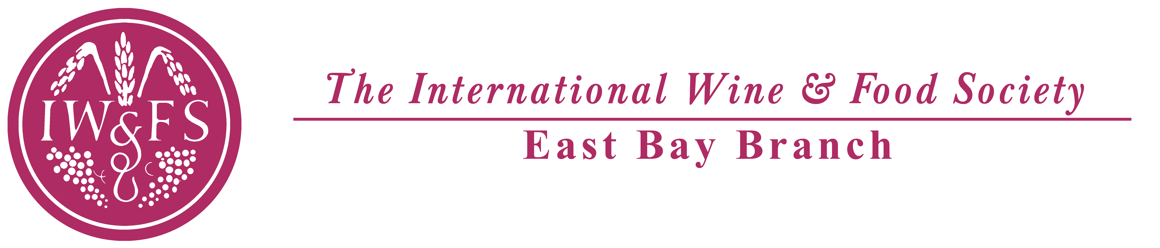

Hors d’oeuvres

Crispy Asian Vegetable Spring Roll
Mango Dipping Sauce

Accompanied with NV Piper-Heidsieck Brut Champagne

First Course

Wild Mushroom Tart with Onion Confit

Paired with 2011 Acacia Pinot Noir, California

Entree

Filet Mignon and Atlantic Salmon
Roasted Shallot Jus

Market Vegetable Wellington

Paired with 2009 Mer Soleil Chardonnay, 1990 Clos d l’Oratoire
and 2009 Sequoia Grove Cabernet

Dessert

Chocolate Knockout Cake
Vanilla Infused Raspberry Sauce, Shaved White Chocolate

Paired with 1997 Warre’s Vintage Port

Coffee and Tea

