**International Wine & Food Society**

***Council Bluffs Branch***

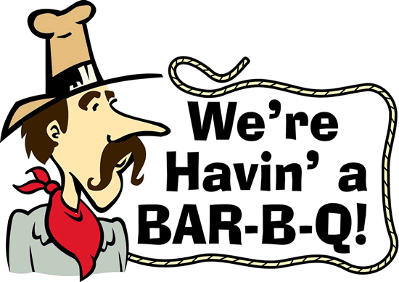

**Baby Back Barbeque Picnic**

**Chef - State Barbeque Champions Leonard & Julie Hawkins**

**June 3, 2017**

**Nate & Liz Farmer’s Home**

3348 South 226th Circle, Elkhorn NE 68022

Quaffing 6:00 PM Dinner 6:45 PM

***Appetizers***

***Jalapeno Poppers & BBQ Shrimp***

***Reception Wines***

**2016 Dog Point Sauvignon Blanc JS-93 V-92 RP-90**

**Whispering Angel Rose Cote de Provence JS-92**

**2015 Domaine Chignard Les Moriers Fleuries JS-95 V-93 RP-91**

**Main Course**

**Chicken, Brisket, Baby Back Ribs**

**Sides**

**Corn Confetti Salad, BBQ Peach Beans**

**Corn Bread & Butter**

**2015 Hartford “Old Vines” Russian River Zinfandel RP-95 WS-94**

**2015 Bonnhoff Reisling Spatlese Norhiemer Kirschheck Nahe WS-93 WA-91**

**2013 Catena Alta Malbec RP-94 D-92 JS-94**

**2015 Hentley Farm Shiraz Barosso Valley JH-95 WS-92 RP-90**

**Dessert**

**Home Made Pear Pie**

**Pacific Rim Reisling WS-92 WE-91**

**Event Organizers: Liz & Nate Farmer, Patti & Steve Hipple, Donna & Lowell Wilhite**

**Dress: Summer Casual**

**Cost:** $90 per person. Email Patti at [stephenhipple@hotmail.com](mailto:stephenhipple@hotmail.com) to confirm your reservation. Mail check to Patti Hipple, 3101 Washington St., Bellevue NE 68005 by May 28th.