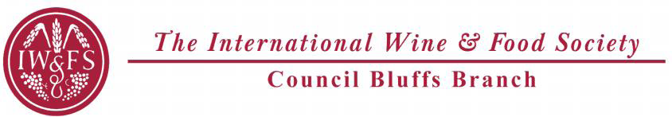

International Wine and Food Society
Council Bluffs Branch
A Taste of Germany
Council Bluffs Country Club
4500 Piute St
Council Bluffs, Iowa
Friday, November 18, 2016 Quaffing 6:00pm, Dinner 6:30 pm
Dress: Country Club Casual
Quaffing
“Laugenbrezel” Soft Pretzel with German mustard and dips
“Matjes” Salted herring “Wurstchen” Assorted German sausages
Urban Reisling 2014 90, other reds

Erster Enterricht
“Schnitzel 3 ways” Jaegerschnitzel, Holsteinerschnitzel, und Ziegeunerschnitzel
Mit Bartkartoffeln (panfried potatoes)
Willi Schaefer Graacher Himmelreich Reisling Kabinett 2011 92WA,
Fredrich Becker “B” Pinot Noir Pfalz 2012 94WE
Suppe
“Zweibelsuppe” Creamy onion and apple gratinSchafer-Frolich Brockenauer Kabinett 2013 WA91 WS90
Salat
“Spargelsalat” White asparagus, radish, tarragon chive dressing
Hauptkurs
“Sauerbraten” Sweet and sour beef short rib, buttered spaetzli, rotkohl (braised red cabbage)
Willi Schaefer Graacher Domprobst Riesling Spatlese “#5” 2011 95WA
Kase Naturlich
“Cambozola” Prepared hot & cold with pears and rye crackers
Donnhoff Brucke GoldKapsel Reisling Auslese 2011 94WS
Dessert
Bienenstich (German Bee Sting Cake)

Executive Chef: Jeremy Buthe
Event Organizers: Tom and Jeanette Schierbrock/Tom Murnan &Steve Hipple
Cost: $115
Make check pay able to CB IWFS and send to Tom Schierbrock at 512 Forest Glen Drive, Council Bluffs Iowa 51503 by Nov 14. (There is a three day prep time for the Sauerbraten)
Dinner is limited to 32 people
Any questions please call Tom or Jeanette at 712-323-0642

